**Experiment No.5**

**Aim:**  Edit/compile/run a program to read a four digit number through the keyboard and calculate the sum of its digit.

**Program A:**

def getSum(n):  
 sum=0  
 for digit in str(n):  
 sum += int(digit)  
 return sum  
n=2809  
print(getSum(n))

**Output:**

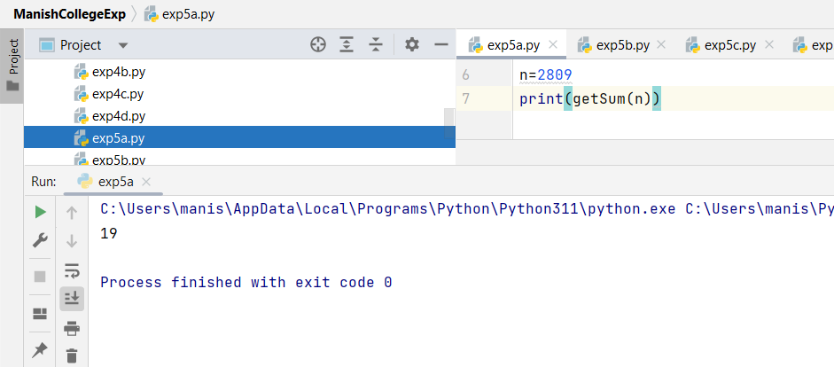

**Program B:**

def getSum(n):  
 sum =0  
 while(n!=0):  
 sum=sum+(n%10)  
 n=n//10  
 return sum  
n=2542  
print(getSum(n))

**Output:**

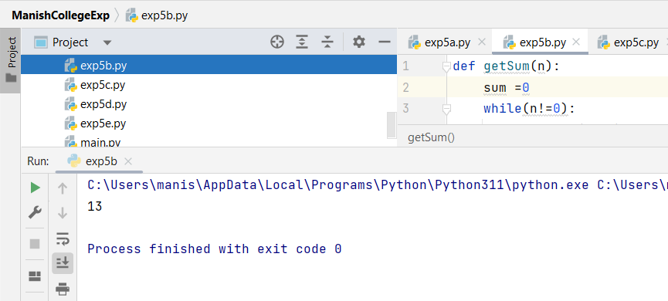

**Program C:**

def sumDigits(no):  
 return 0 if no==0 else int(no%10)+sumDigits(int(no/10))  
  
no= 6842  
print(sumDigits(no))

**Output:**

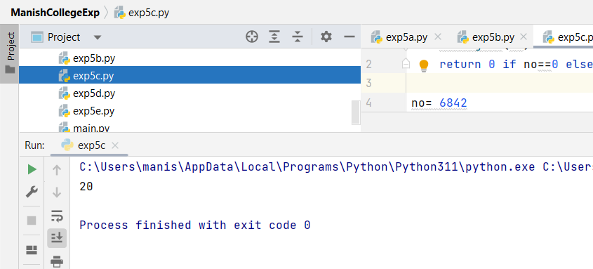

**Program D:**

def getSum(n):  
 strr=str(n)  
 list_of_number = list(map(int, strr.strip()))  
 return sum(list_of_number)  
  
n = 2587  
print(getSum(n))

**Output:**

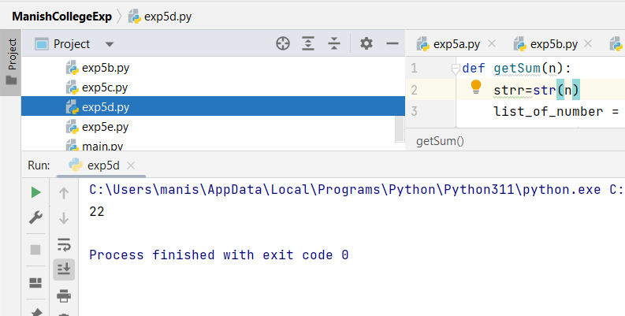

**Program E:**

number = input("Enter a four-digit number: ")  
if len(number) == 4:  
 sum_of_digits = int(number[0]) + int(number[1]) + int(number[2]) + int(number[3])  
 print("The sum of the digits is:", sum_of_digits)  
  
else:  
 print("Error: You must enter a four-digit number.")

**Output:** If 4 digits are entered correctly:

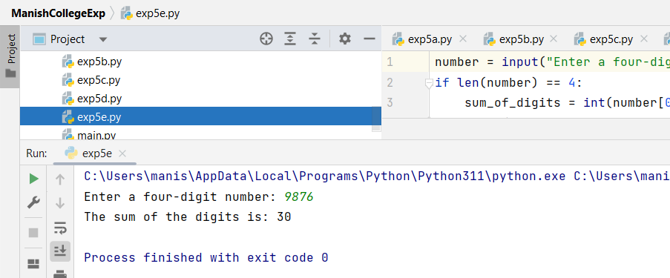

**Output:** If 4 digits are not entered:

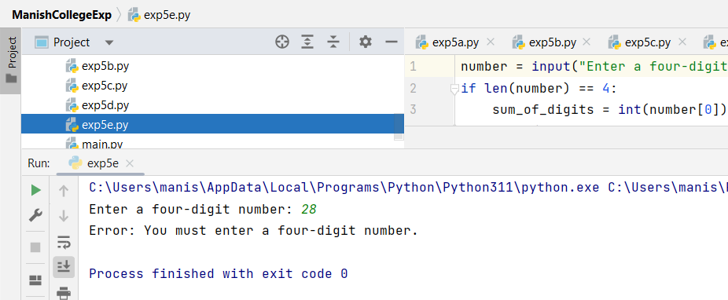

|  |  |  |  |
| --- | --- | --- | --- |
| **Practical Performance**  **(4)** | **Writeup & Oral**  **(4)** | **Attendance**  **(2)** | **Total**  **(10)** |
|  |  |  |  |